The Control & Computing System hardware consists of:

* **Flight Control System**

1. Pixhawk 2.4.8 (ARM Cortex M4, 6-axis gyroscope + accelerometer, barometer, compass, failsafe co-processor)
2. NEO-M8N GPS Module (Accuracy of 2m & 18 Hz update rate)

* **Flight Computing System**

1. Raspberry Pi Model 4 B (4GB RAM)
2. Raspberry Pi Night Vision Camera (5MP, 1080p)

* **Telemetry**

1. 433 MHz 500mW radio telemetry (2.5km range)

The hardware for control system is selected after detailed analysis of all available options in terms of cost (time & money), reliability and mission limitations. Control and Computing System, both are put inside UAV for two reasons:

1. **Complete autonomy of UAV:**

UAV is independent of any ground control station and can complete spraying mission outside range of telemetry with great precision.

1. **Advanced Computing & Artificial Intelligence:**

Using machine learning, advanced model-prediction algorithms & artificial intelligence on powerful quad-core Raspberry Pi, the on-board computing system makes this UAV the first of its type; out-performing any manned or unmanned agriculture drone in market.

1. **Image Processing:**

The Raspberry Pi Night Vision Camera enables the drone to capture high quality images in the day as well as night. In order to process these images, we would be using Open-CV written in C++ which allows the processing of the image at a very fast speed. This would allow the drone to be able to do real-time computer vision.

In addition to Open-CV, the drone is equipped with YOLO (You only look once) algorithm for real time object detection using Machine Learning. This would allow the drone to be completely autonomous since it would be able to recognize objects in the images of the camera and make movements according to the landscape.

Controller and Computer are present on different adjacent boards inside UAV. Schematic below shows the rough idea of electrical connections (not the original electrical schematic, just rough schematic for better understanding).

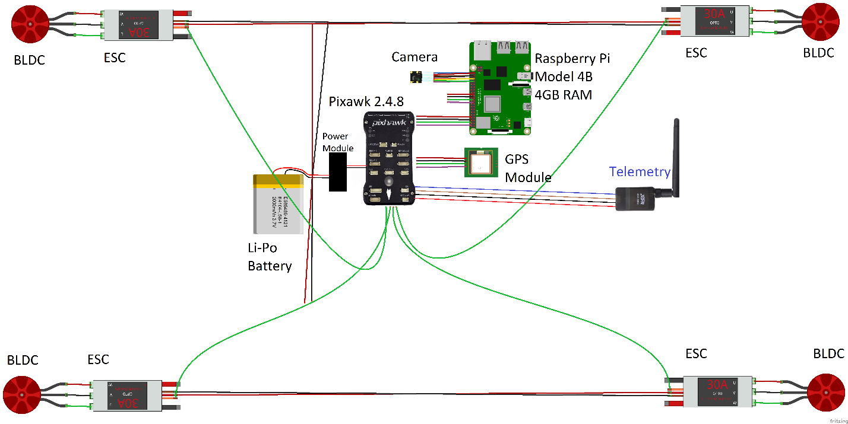

A far more performance efficient approach would be to embed the flight controller (ARM Cortex-M4 + 32-bit failsafe co-processor), all control sensors (MPU6000, ST micro gyroscope + magnetometer), flight computer (ARM Cortex-A72, SRAM, DRAM) and all peripherals on a single PCB. This would greatly reduce the wiring across all avionics. Main issue in this approach is fabrication of this all-in-one PCB. It is estimated to be minimal of 6-layer PCB with <150µm scale which isn’t available in Pakistan. Moreover, designing all connections, power optimization, signal latency & area optimization require more time and effort. Depending upon time & resources available, this doesn’t seem impossible to achieve in near future.

**Flight Controller Software:**

Pixhawk runs modified ArduPilot firmware for quad tilt-rotor UAV with all 4 rotors tilting. Modifications in the firmware are made for optimum performance with our UAV’s aerodynamic specifications. Modifications include:

* Vertical to Horizontal or Horizontal to Vertical Flight Transition with variable tilt-angle (enabling both time & energy optimization according to requirements)
* Drone stabilization by controlling all 4 tilting servos on independent PIDs (for optimum stability)
* Shifting Telemetry to Flight Computer in order to enhance performance of control loops in flight computer since there is only one core in Pixhawk (ARM Cortex-M4)